Name :

Abubaker Attique

Roll no :

P20-0560

Section :

5-A

Task 1:

a)

Description :

We will assign the static ip by clicking on the router and then click on static :

Some router are conmnected directly to the router some are not so we will assign the static ip :

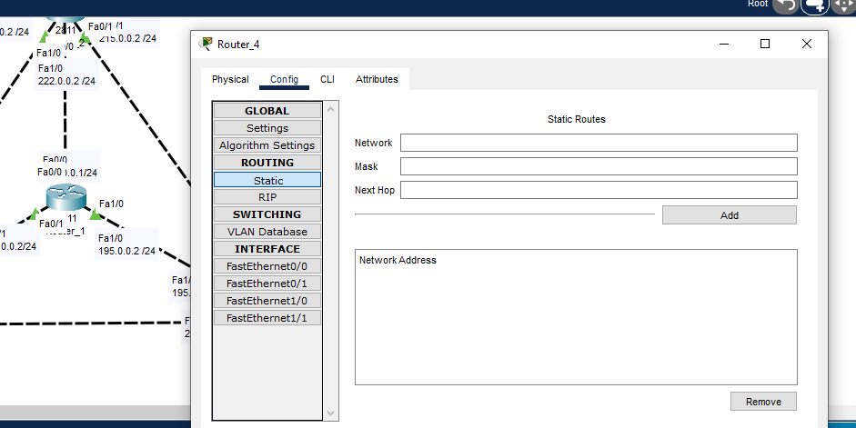

Router 4 to router 2

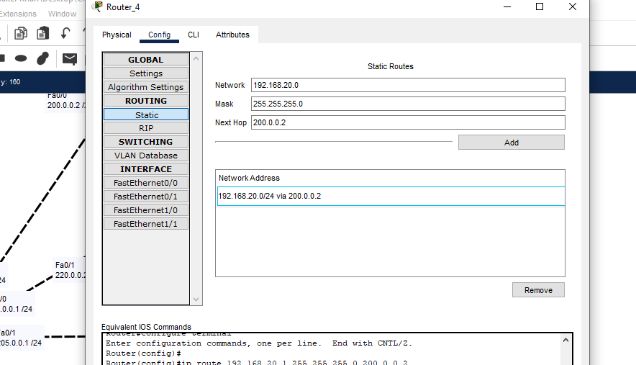

Router 4 to router 1

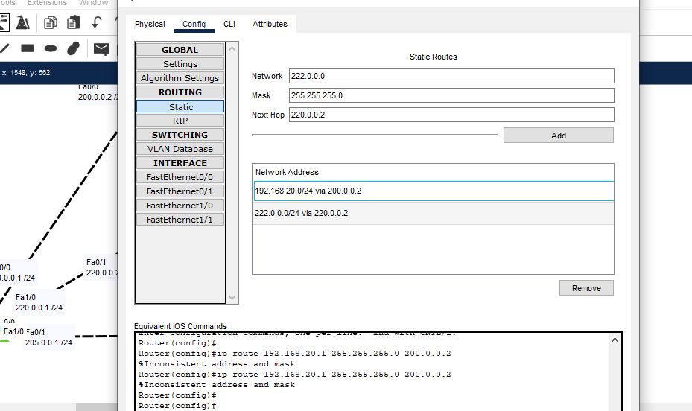

Router 4 to router 2 Fa0/1

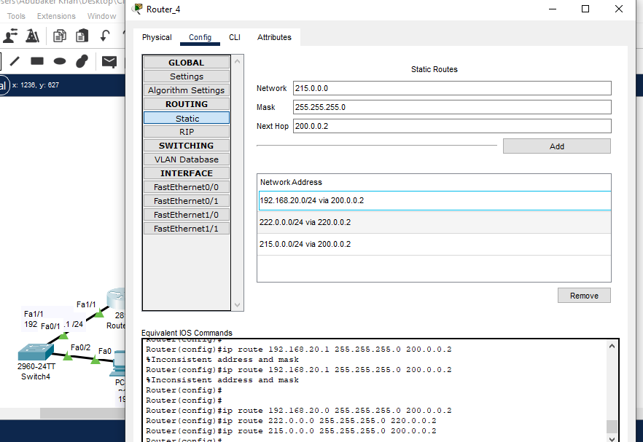

Router 4 to touter 3 Fa0/0

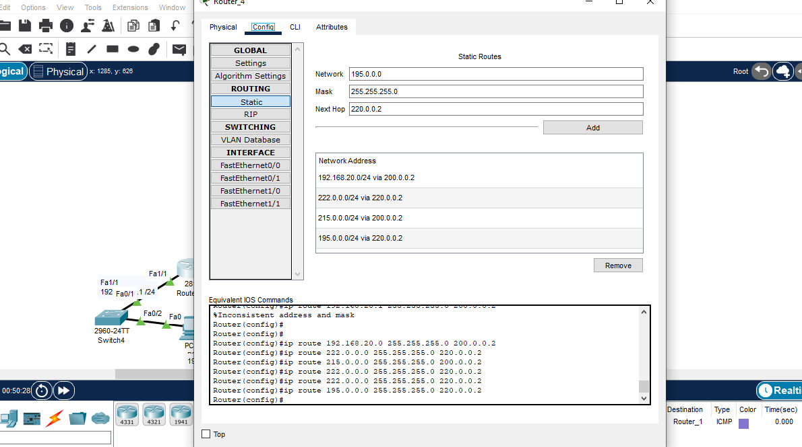

Router 4 to router 3 Fa1/1

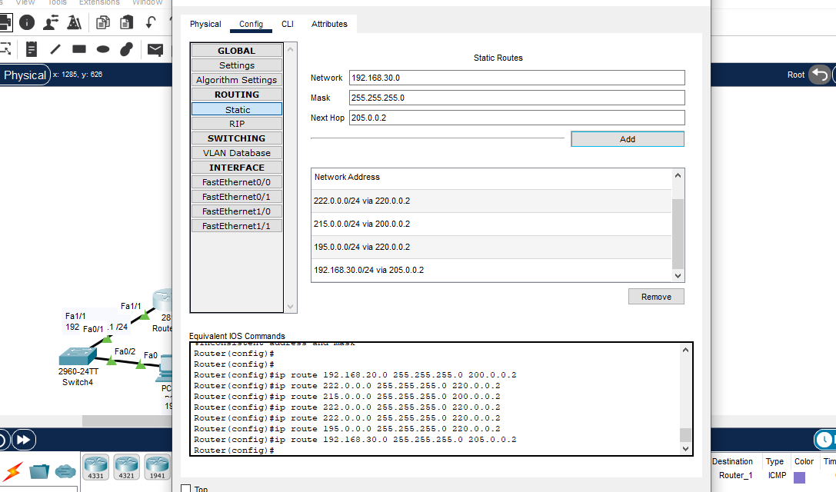

Router 4 to router 3 fa0/0

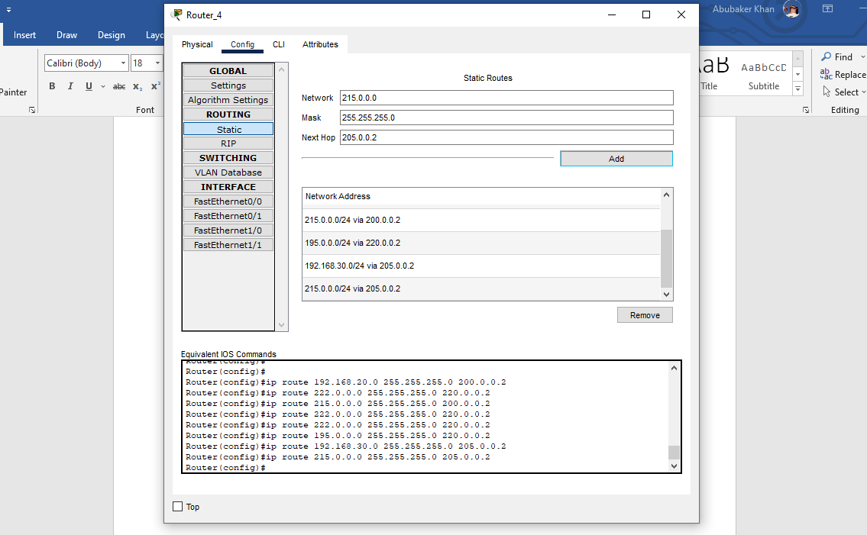

Router 4 to router 3 1/0

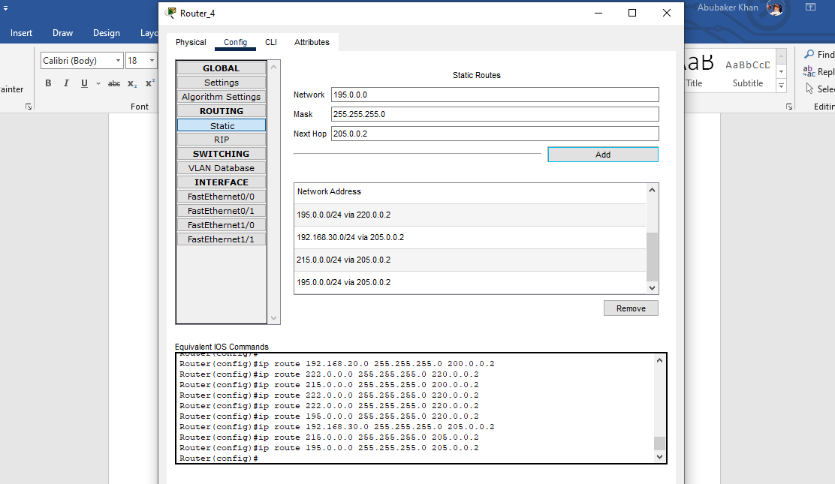

Router 4 to router 2 fa1/0

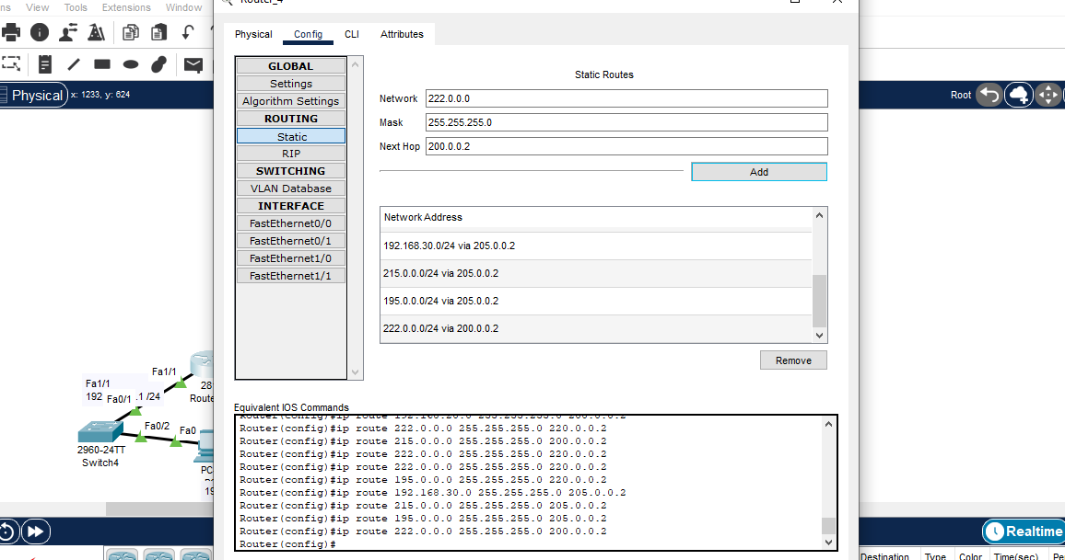

Router 4 to router 1 fa0/0

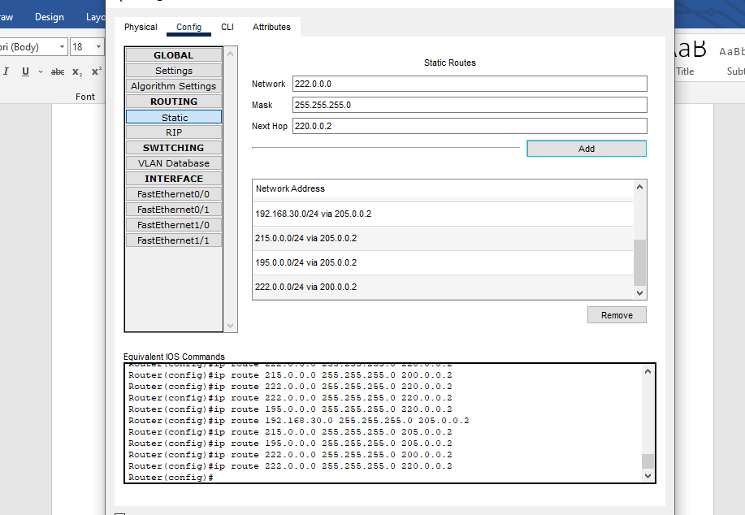

Now these all step will be again doing for router 1,2,3

NOW DOING FOR ROUTER 1:

Router 1 to 2 fa0/0

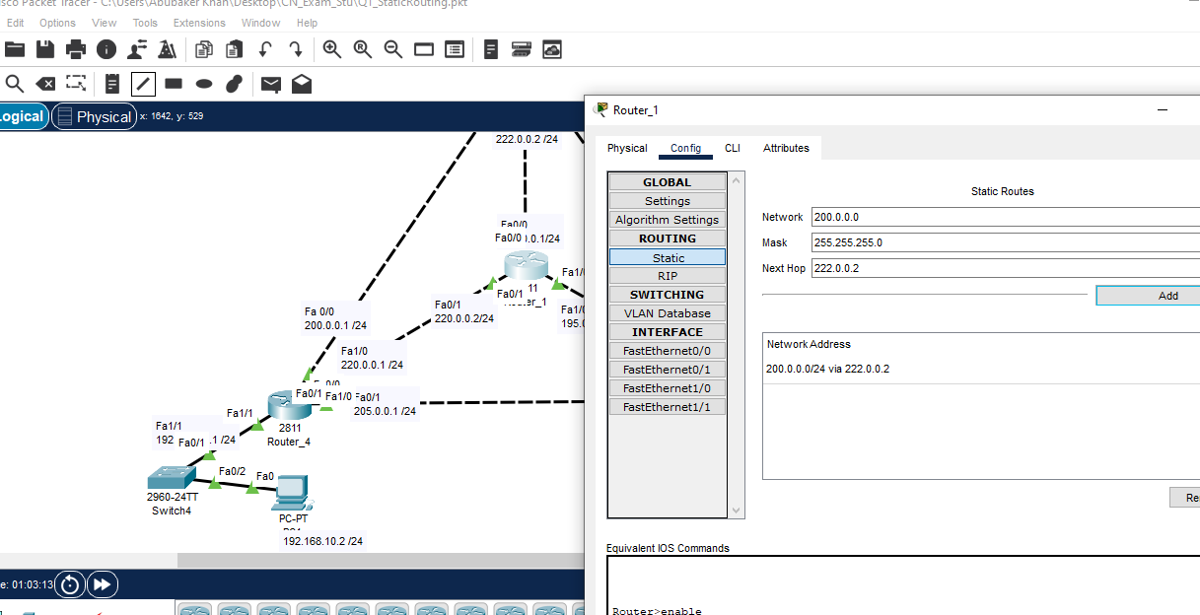

Router 1 to 2 fa1/1

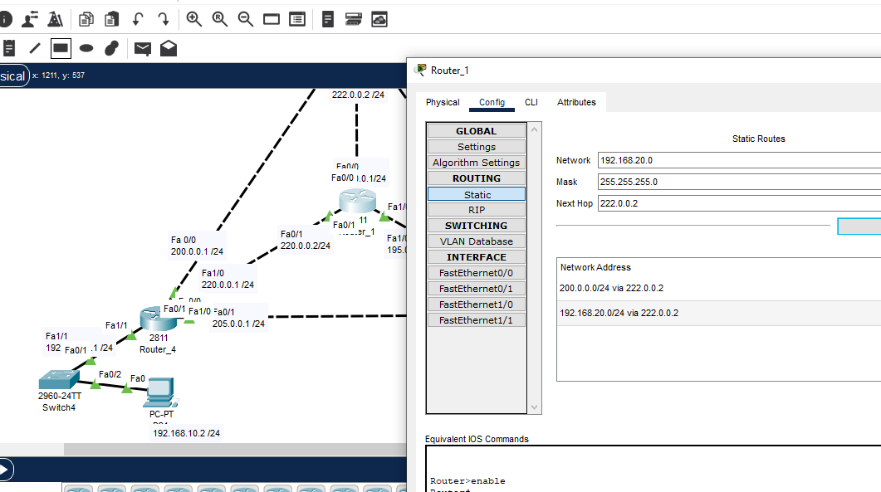

Router 1 to 2 fa0/1

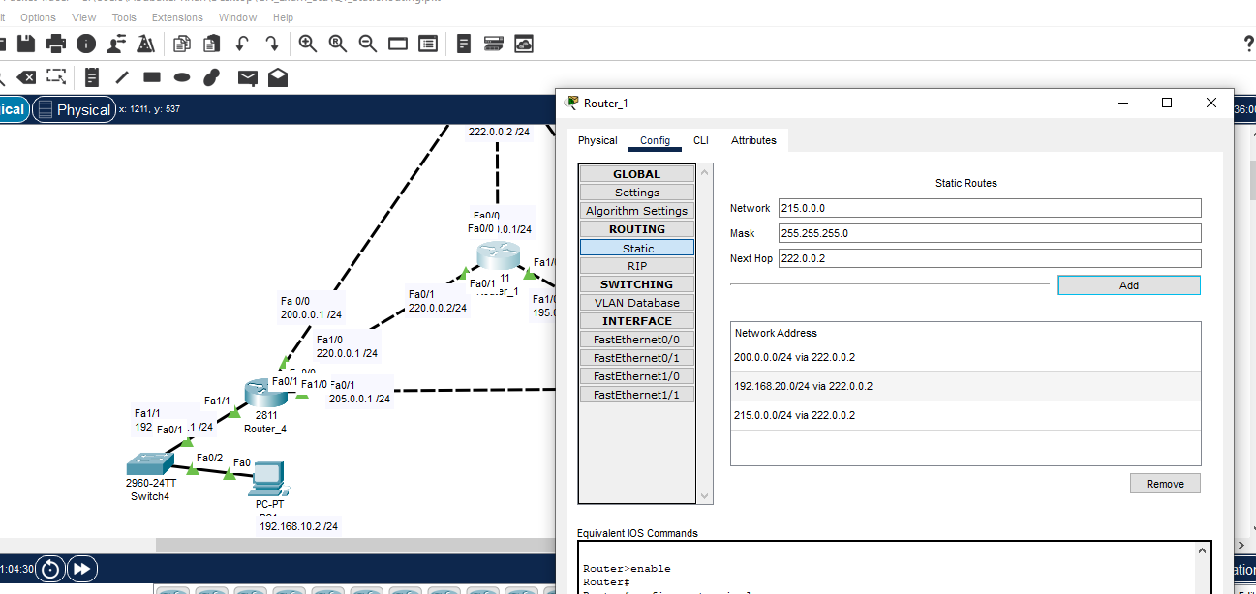

Router 1 to 3 fa0/1

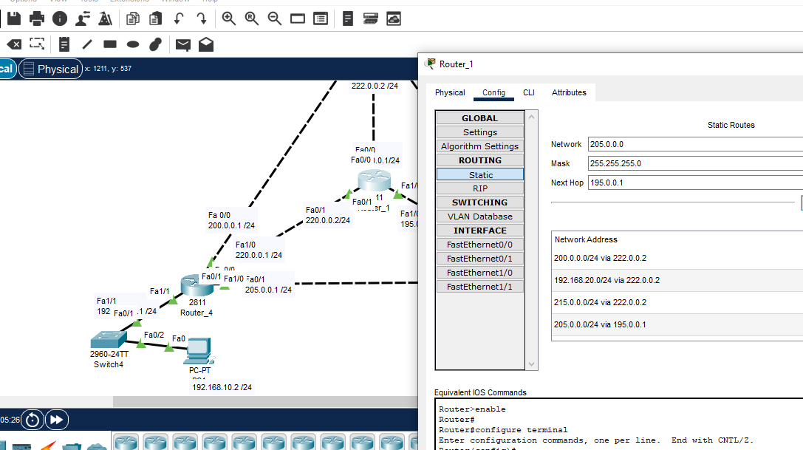

Router 1 to 3 fa1/1

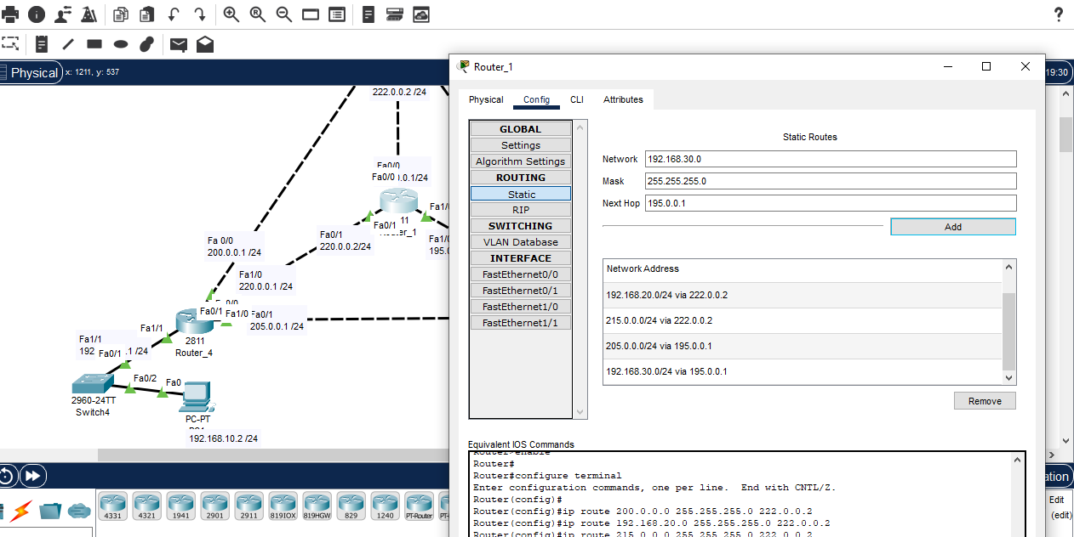

Router 1 to 3 fa0/0

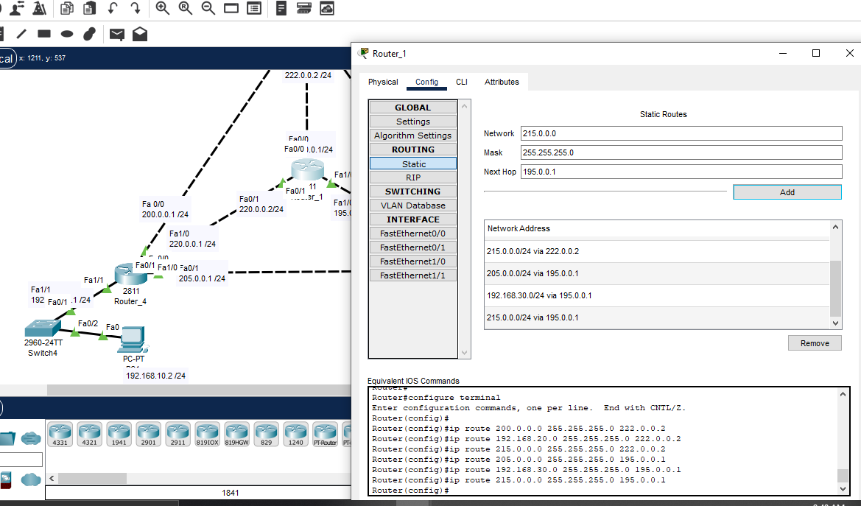

Router 1 to 4 fa0/1

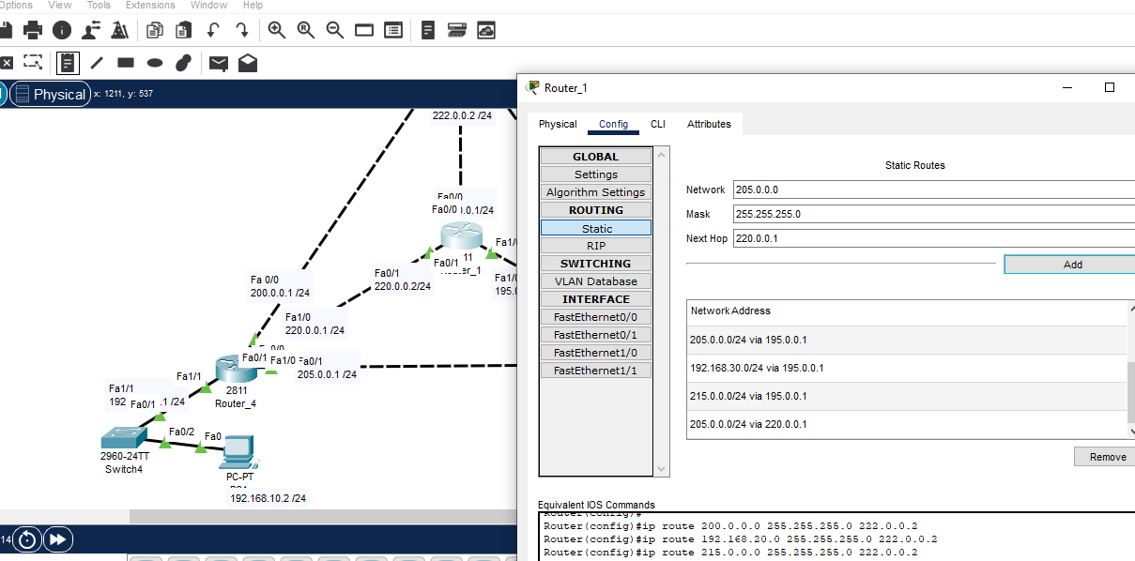

Router 1 to 4 fa1/1

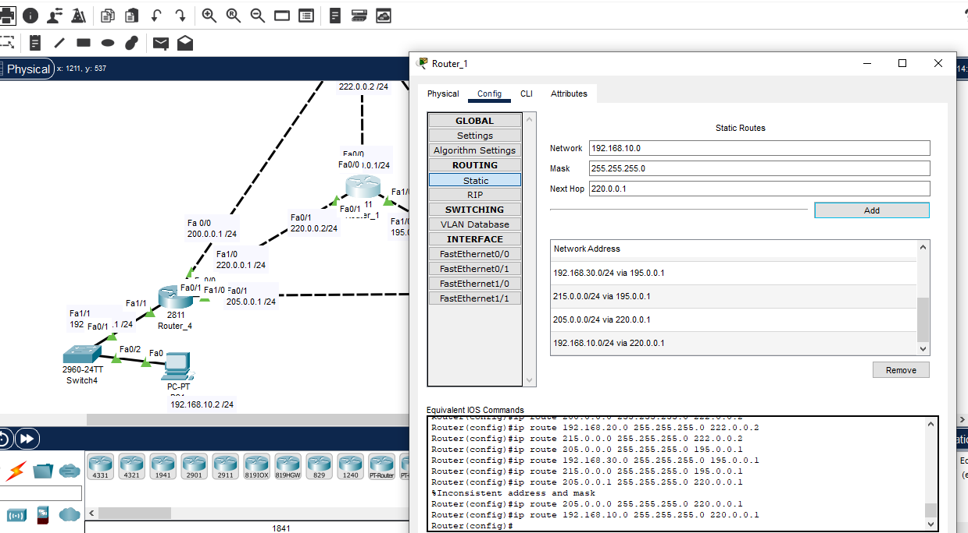

Router 1 to 4 fa0/0

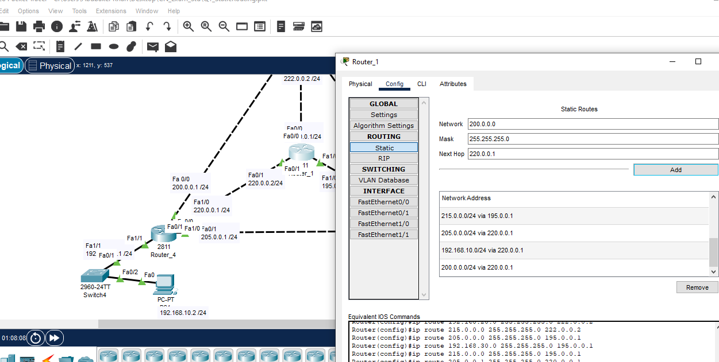

Now for router 2

Router 2 to 1 fa0/1

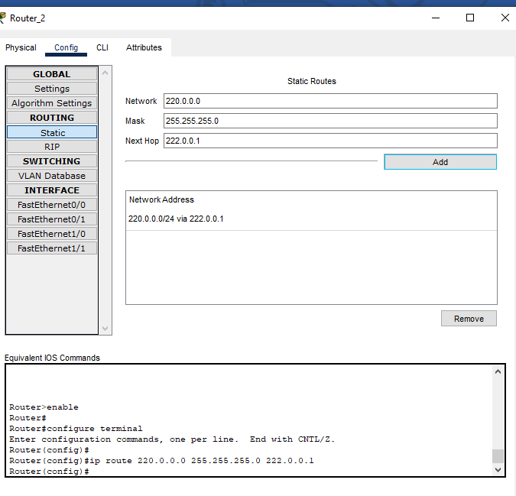

Router 2 to 1 fa1/0

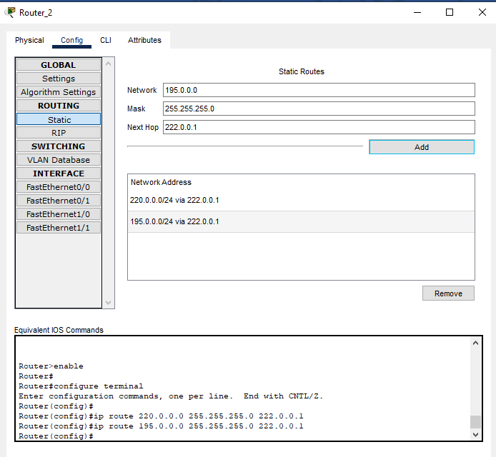

Now router 3:

Router 3 to 1 fa0/0

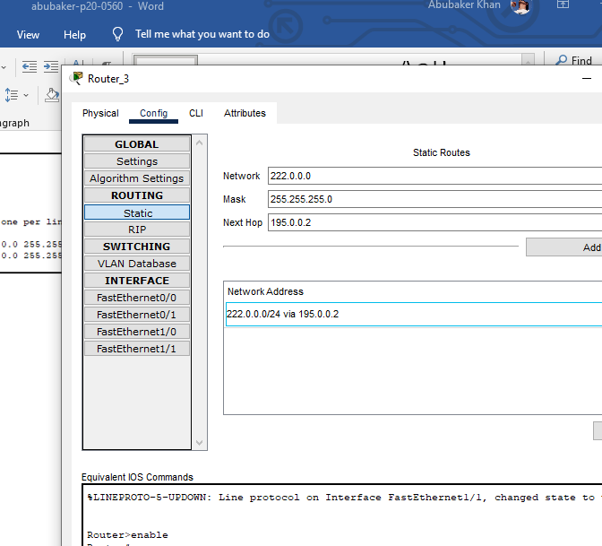

Router 3 to 2 fa1/1

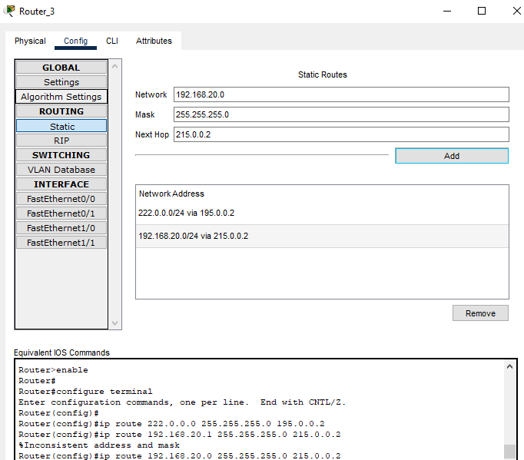

Router 3 to 4 fa1/1

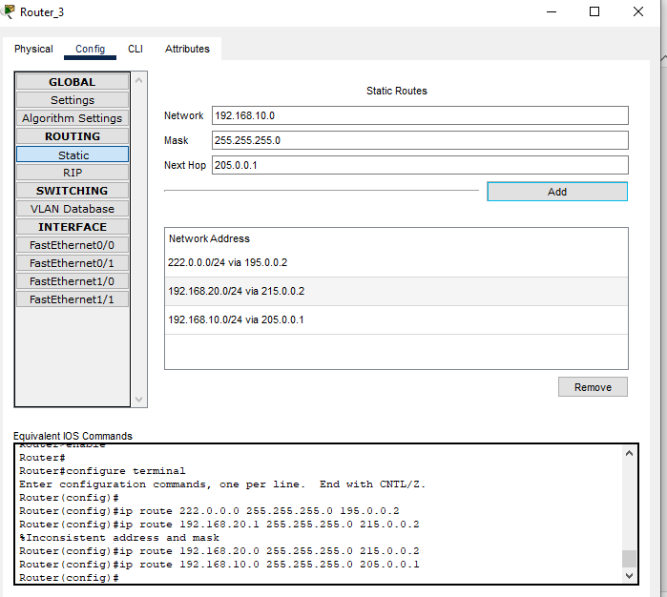

Router 3 to 4 fa0/0

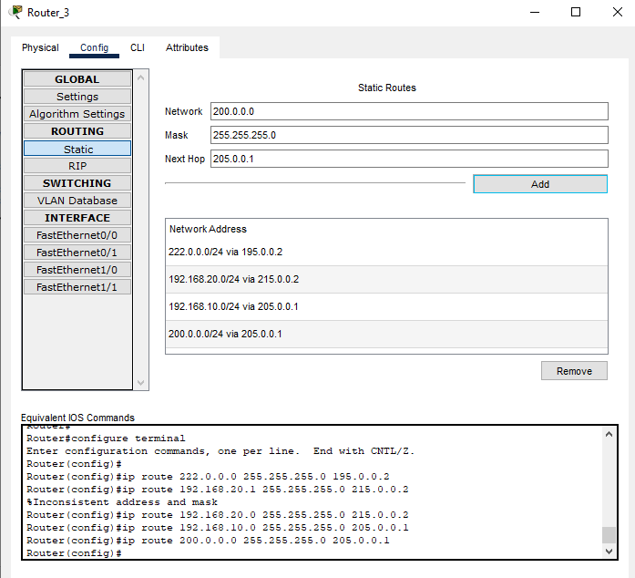

Router 3 to 4 fa1/0

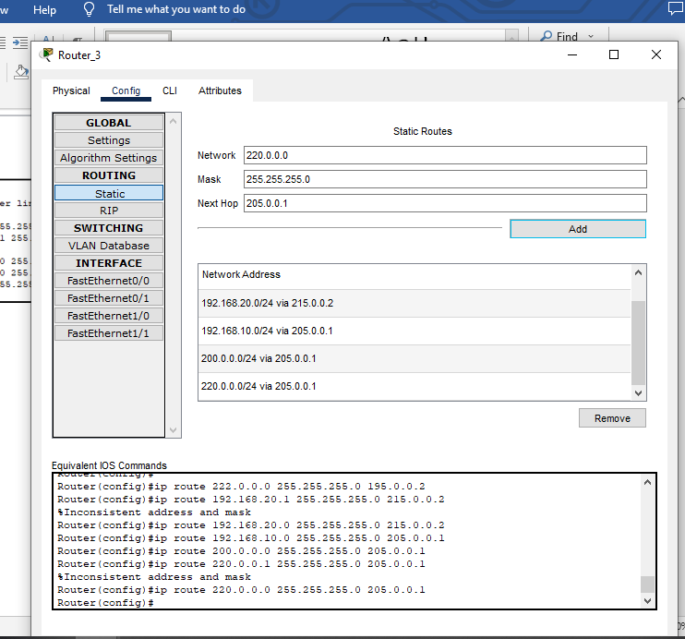

Connection test :

For this we will ping from onr pc to other

Following is from pc1 to pc2

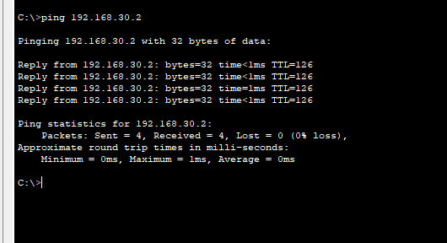

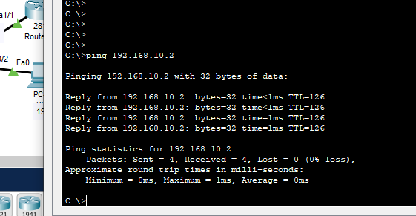

Question 1 : part b:

Now we will add dhcp server in given topology:

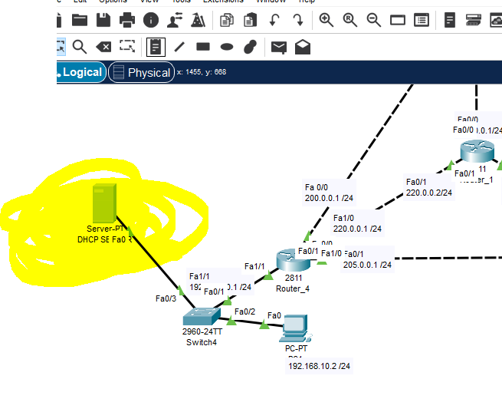

After adding dhcp server we will assign the ip address staticly

Which is 192.168.10.3.

Subnet mast is 255.255.255.0

Default gateway 192.168.10.1

Dns server : 192.168.10.4

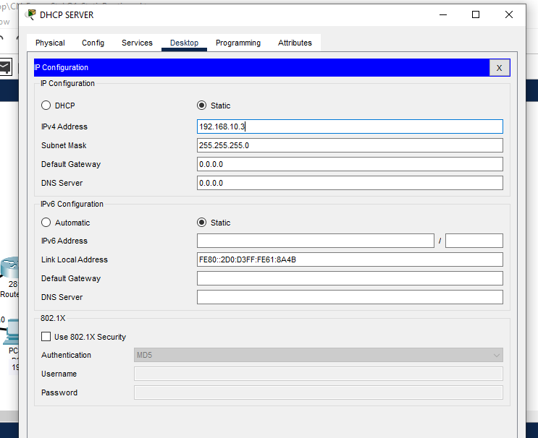

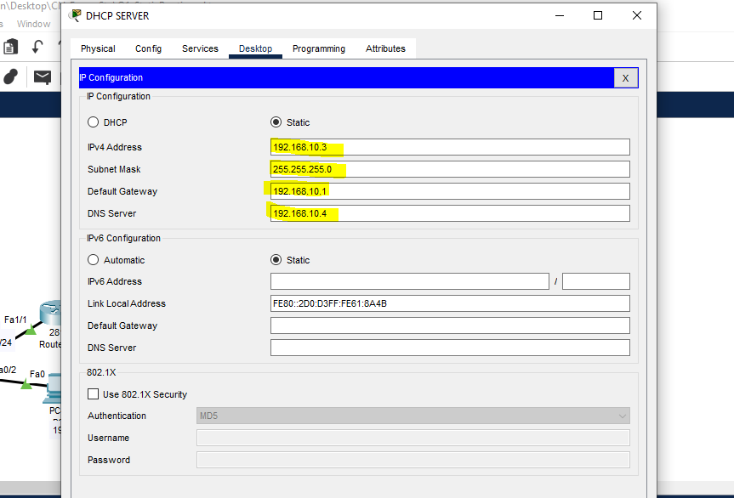

IP s are assign to dhcp server .

Now we will create pool for the network

By clicking on services

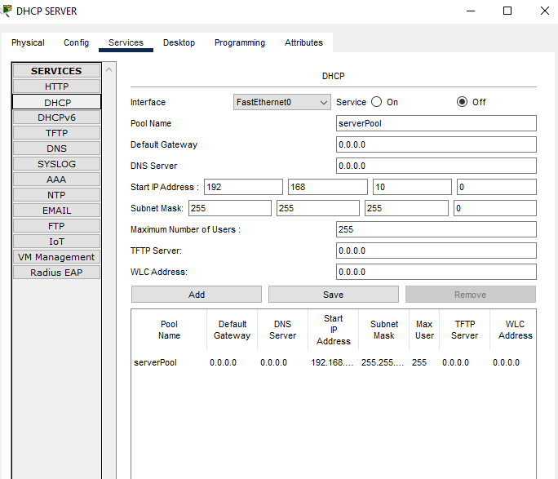

Pool name: serverpool

Default gateway: 192.168.10.1

Dns : 192.168.10.4

Starting ip :192.168.10.11

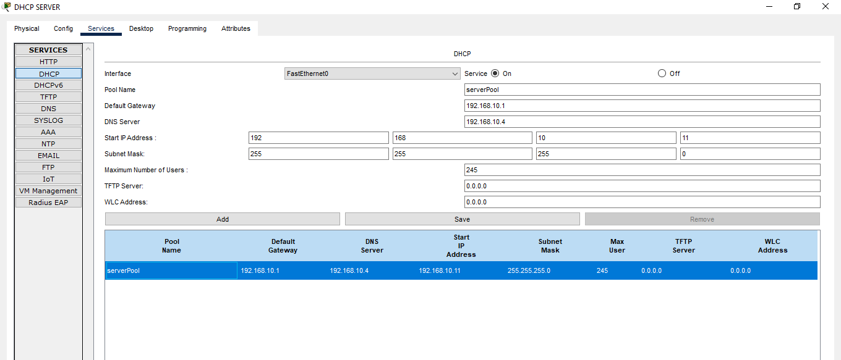

Now creating pool 192.168.20.0

Default gate : 192.168.20.1

Subnet mask : 255.255.255.0

Dns: 192.168.10.4

Stating ip: 192.168.20.11

Pool name : pool2

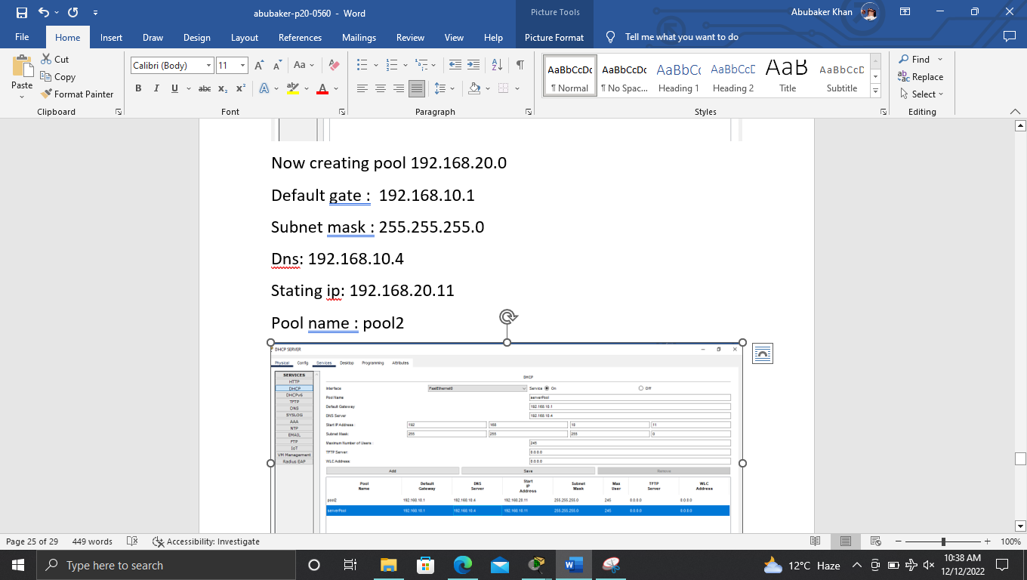

Now creating pool for 192.168.30.0

Default gate : 192.168.30.1

Subnet mask : 255.255.255.0

Dns: 192.168.10.4

Stating ip: 192.168.30.11

Pool name : pool3

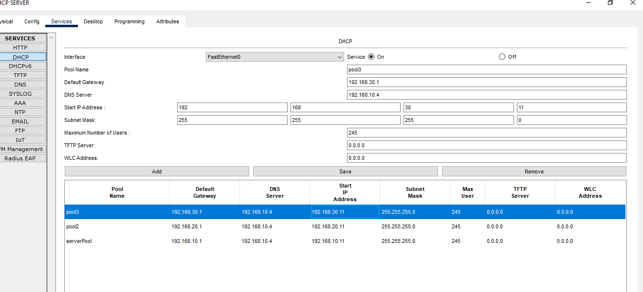

===================================================

Question 2:

1.

Answer : we are going to make network for Mastertech.

Following are the requirement:

* we need dhcp server to assign the ips dynamically
* we need email server
* we need web server
* we need dns server
* we need 2 router
* we need 3 sweitches
* we need 6 pcs
* we will be using given ip which is fixed. 220.10.10.0 and its subnet mas is 255.255.255.0 its class c ip

====================================================

2.

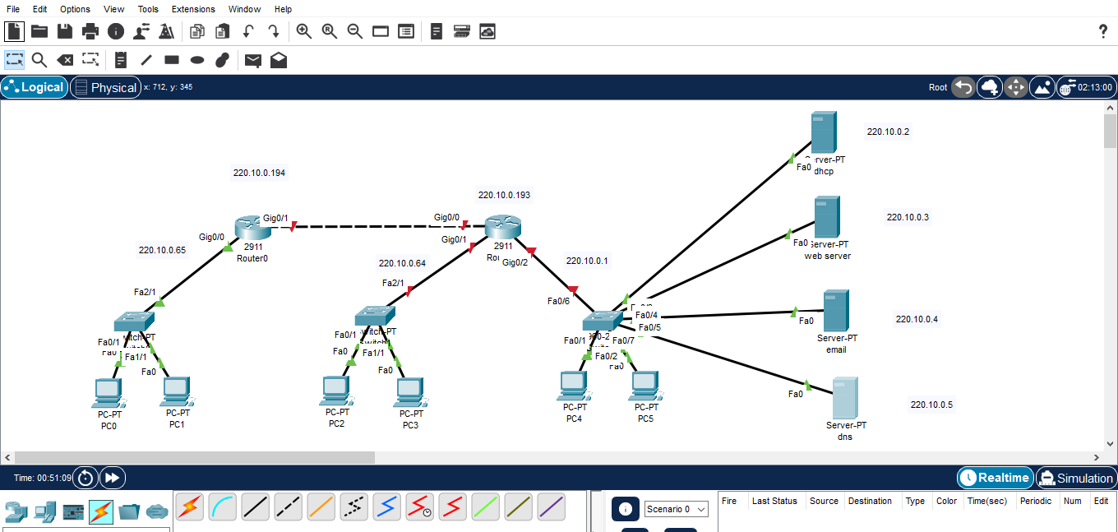

Ip given to dhcp:

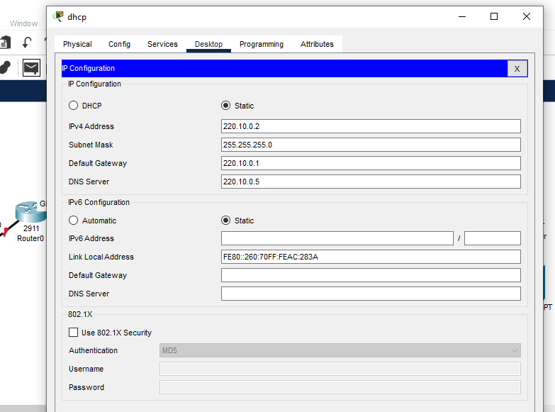

Ip fiven to email:

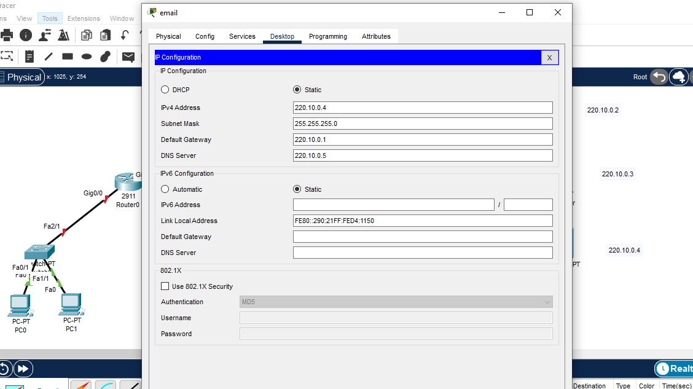

Ip given to web:

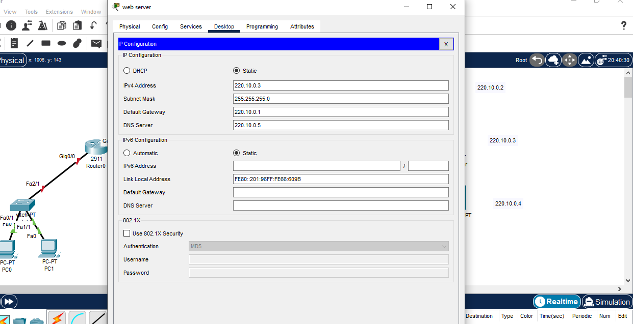

Pool created for all gateways:

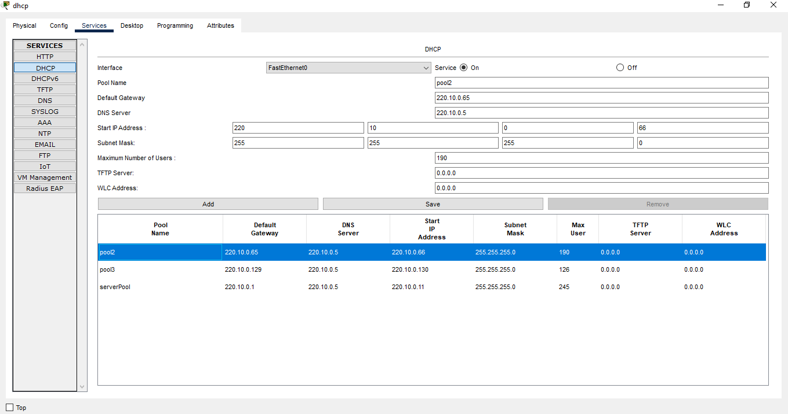

3.

1. Based on the topology ,how many subnets are needed ?

**Ans:** we need to create 4 subnets.

1. How many bits must be borrowed to support the number of subnets in the topology ?

**Ans:** we need to borrowed 2 bits from the host parts where 3 for department and 1 for router connection.

256/4=62 ip

1. How many subnets does this create ?

Ans: it will create 4 subnets.

1. How many usable hosts does this create per subnets ?

Ans: 256/4 = 64-2=62

62 ips are usable

1. What is the new subnet mask in dotted binary format ?

Ans: 111111111.11111111.11111111.11000000

1. What is the new subnets mask in the dotted decimal format ?

Ans: 255.255.255.192

1. Fill in the following table with the subnet information:

|  |  |  |  |  |
| --- | --- | --- | --- | --- |
| Subnet number | Subnet address | First usable  Address | Last usable  Host add | Broadcast  address |
| 1 | 220.10.0.0 | 220.10.0.1 | 220.10.0.62 | 220.10.0.63 |
| 2 | 220.10.0.64 | 220.10.0.65 | 220.10.0.126 | 220.10.0.127 |
| 3 | 220.10.0.128 | 220.10.0.129 | 220.10.0.190 | 220.10.0.190 |
| 4 | 220.10.0.192 | 220.10.0.193 | 220.10.0.254 | 220.10.0.255 |
|  |  |  |  |  |
|  |  |  |  |  |

4.

Answer :

For netting

200.10.10.0—we create pool 200.0.0.0

5.

